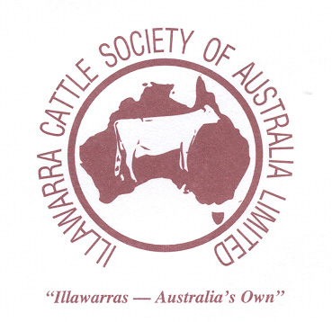

Domar Nighthawk
Silverleigh Monarch Subliem Tulip Red Aug 2007 ABVAPR –17 Rel. 76%
Aug 2007 ABV Aug 2007 ABV
APR: +125 Rel. 65% APR: + 40 Rel. 96%
M +783 P+25kg @ 0.07% F+67kg @ +0.48% Rel. 80% M -369 litres P-3kg @ +.013% F+32 @ 0.68% Rel 99% Batenburg Tina 824-R Vg 86
Overall Type +0.5 Mammary System +0.6 Rel. 39% Overall Type +0.4 Mammary System +0.8 Rel. 94% 2-03 8974 M 326P @ 3.5% 432F @ 4.7%
3-03 9447 M 341P @ 3.5% 448F @ 4.6%
4-06 10500 M 366P @ 3.4% 472F @ 4.4%

Silverleigh Mima Vg Wilmington Virgins Ruler
Aug 2007 ABVAPR –90 Rel. 92%

Silverleigh Miriam Vg

Treeton Princess 919 Vg-86 Venvale Prince Glenafton Enhancer
2-01 6426 M 213 P @ 3.3% 206 F @ 3.2% APR: + 63 Rel. 96% Aug 2007 ABVAPR +18 Rel. 99%
3-06 8124 M 278 P @ 3.4% 338 F @ 4.2% M +680 litres P+13kg @ -.01% F+28 @ -0.01% Rel 98%
Honourable Mention Cow IDW 07’
Reserve 4yr old in milk Real Australia Photo Competition 07’ Venvale Pearl 64th Ex-1E

Treeton Princess 700 Vg-85 Glenbrook Treaty
1-11 6284 M 206 P @ 3.3% 238 F @ 3.8% Aug 2007 ABVAPR +60 Rel. 89%
2-11 8310 M 298 P @ 3.6% 318 F @ 3.8%
4-00 9047 M 297 P @ 3.3% 285 F @ 3.2%
5-60 10363 M 325 P @ 3.1% 379 F @ 3.7% Treeton Princess 86 Gp-84
1st 18 Months Royal Adelaide Show 01’ 3-00 8097 M 281P @ 3.5% 283F @ 3.5% 1st 2yr old dry Mt Pleasant Show 02’ 4-00 9804 M 334P @ 3.4% 361F @ 3.7% 5-11 10350 M 350P @ 3.8% 390F @ 3.8%

